**SAMPLE PROJECT-6**

**COMPLIANCE MONITORING AND**

**REPORTING﻿**

**(GOTLA SHIVANI YADAV)**

**AIM -What is the aim of analysis**

• Metrics:  
1. Number of compliance breaches  
2. Time to compliance for new regulations  
3. Compliance training completion rates  
4. Audit findings and scores  
5. Fines and penalties  
6. Incident response times  
7. Number of suspicious activity reports (SARs)  
8. Regulatory change impact assessments

**FEATURES**

* Compliance Breaches -The number of times compliance regulations were breached.
* Time to Compliance Days -The number of days it takes to achieve compliance after a breach or non-compliance event.
* Training_Completion_Rate- The percentage of employees who have completed required training programs.
* Audit Findings -The results of audits, including any issues or irregularities identified.
* Audit Score-A numerical score representing the overall result of an audit.
* Fines and Penalties Amount- The monetary value of fines and penalties incurred due to non-compliance.
* Incident Response Times -The time taken to respond to and resolve incidents.
* Suspicious Activity Reports -: Reports of suspicious activities that may indicate fraud or other illicit behavior.
* Regulatory Change Impact Score-A score indicating the impact of regulatory changes on the organization.
* Department-The department within the organization that handles the issue such as operations, finance, marketing etc.
* Employee Id-A unique identifier for each employee.
* Location-The geographical location of the department or employee.
* Quarter -The fiscal quarter in which the data was recorded.
* Year-The fiscal quarter in which the data was recorded.
* Compliance Manager- The fiscal quarter in which the data was recorded.
* Training_Session_Attended -determines wheatear the training session is attended
* Audit Type-The type of audit conducted (e.g., internal, external, compliance).
* Regulation ID-A unique identifier for each regulation relevant to the organization.

**METHODOLOGY**

* Data collection – data is collected for the following metrices
* Data cleaning – data is cleaned with the use of SQL – where the null values of numerical are replaced with the mean values and categorical values are replace with the mode. There by the outliers are removed and values recording is done.
* Data analysis – the data cleaned is analyses using Power BI with various charts and give meaning full insights

**OUTPUT**

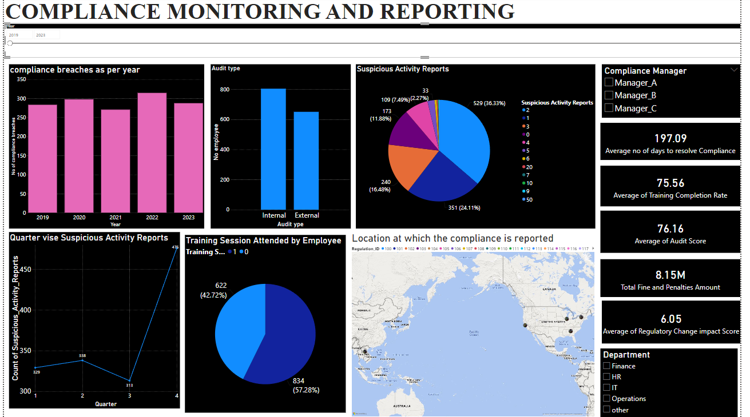

**RESULT ANALYSIS**

* Determines the number of compliance breaches that occurred every year .so with this we can analyse the frequency of compliance breaches over time and also Identify trends in compliance breaches to determine if they are increasing or decreasing. here it is observed that more compliances breaches were occurred in the year 2022 and 2020.
* It is observed that internal audit type is most preferred which is 800
* SAR are Reports of suspicious activities that may indicate fraud or other illicit behavior here it is found that individuals with 2 reports are highest in number and there by 1 followed by 3 and 0 frauds reports in individual is also found which indicates a lesser risk rate associated with suspicious activities which is actually good for other percentages risk assessment is required with continuous monitoring and there by prevent fraud activities.
* 2 slicers were introduced for manager who handle the compliance and department.
* Average dates to solve a non-compliance or breach. determines the efficiency of the compliance team in resolving issues which is on an average 197 days
* Determining the percentage of employees who have completed required training programs which on an average 75.56
* A numerical score representing the overall result of an audit, including any issues or irregularities identified which is on an average 76.16
* The total fines and penalty amount charged is about 8.15 million.
* 6% score has been impacted after the regulations has been changed.
* It is observed that large number of suspicious reports are observed in quarter 475.
* Determine the rate at which the training session attended by the employee. here it indicates 1 as yes, the training session attended and 0 indicates as no. so here almost 57 percentage of employee are trained other 43 percentage should be taken care by identifing gaps in training participation and take corrective actions.
* The area at which most of the compliance is recorded in south parts of US

**OVER ALL ANALYSIS AND SUMMARY**

* Frequency Analysis: Determine the frequency of compliance breaches over time and here it is observed that more compliances breaches were occurred in the year 2022 and 2020
* Trend Analysis: Identify trends in compliance breaches to determine if they are increasing or decreasing
* determines the efficiency of the compliance team in resolving issues which is on an average 197 days. So, with this we can do Performance Benchmarking that is we can Compare against industry standards or internal benchmarks and also Identify opportunities to reduce compliance resolution times.
* The percentage of employees who have completed required training programs ensuring the mandatory training requirements are met so as per analysis it is 75% so gaps are identified in training participation and take corrective actions.
* Audit findings and the scores are analyzed and also the fines and penalty amount charged.
* SARS analysis – it is found that individuals with 2 reports are highest in number and there by 1 followed by 3 and 0 frauds reports in individual is also found which indicates a lesser risk rate associated with suspicious activities which is actually good for other percentages risk assessment is required with continuous monitoring and there by prevent fraud activities.

**THANK YOU**